Project 2 P1- Non-Profit Website Research

by

Yi-Fan Chen

for

“Princess Anne locavore”

**I. Documentation of creative process.**

A Mind Map

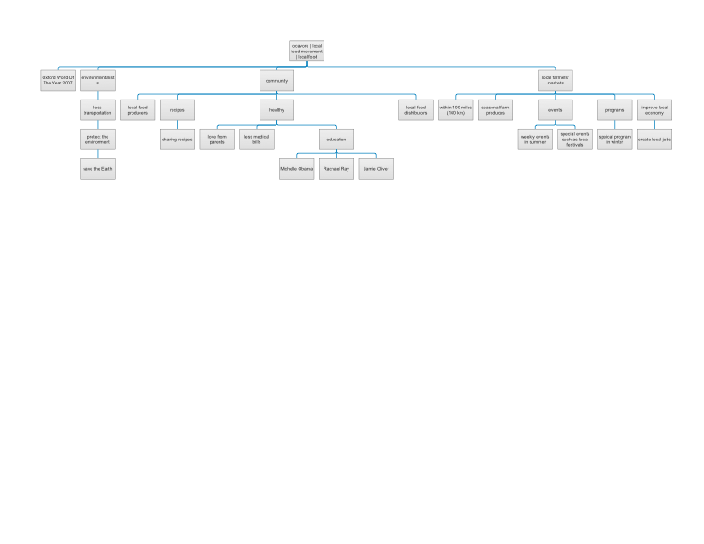

Observation notes



I visited a local famer’s market, Cullipher Farm Market, in Virginia Beach several times last year. At the market that I observed

* Location: 1444 Princess Anne Rd, Virginia Beach, VA 23456
* It is owned and operated by fourth, fifth and sixth generation Culliphers. It has two shops in Virginia Beach.
* The farms are near the Princess Ann store. They produced vegetables and fruits, such as beans, potatoes, and blueberries.
* In summers, both stores are opened to the public. The stores have local fruits, vegetables, milk, eggs that either from Cullipher farms or other local farms, and homemade ice creams, cakes, jams, and pies.
* In summers and falls, the fames are opened to the public to “pick their own” farm produce, such as strawberries, apples, and other fruits.
* In winters, it has a Community Supported Agriculture program (CSA) that members paid 100 dollars pre month to join. In return, the farmer provides a weekly basket of seasonal produce to members.
* Cullipher Farm Market often joined the local events and festivals in summers to sell it produce.

At the store and at the events

* Customers and members seemed to care eating healthy. They did not mind to pay extra to get “quality” produce. The results similar to Darby, Batte, Ernst and Roe (2008) study. Those researchers argued that consumers who have concerns regarding food origin, agricultural production methods, and food safety prefer locally grown food and are even willing to pay more for a local product.[1]
* They shared receipts within customers and owners of the shop.
* Customers and members often visited the shop with family members together.
* Customers and members seemed to be upper-middle-class, females mainly. Many of them were seen with small children together.
* Many of members mainly purchased produce from the local famers’ market. Some of them identified themselves as vegetarians.
* Members seemed to be proud of themselves to support local famers and local businesses. Many of them were living in the area for years/ generations.
* Many of the members visited the shop every week.
* The owners answered all questions from what type of produce grows in their farms, where produce in the shop comes from, how to make apple pies, weather, etc.

**II. Different research methods and data**

Online research about locavore and locavore in Virginia Beach

locavore in general

* locavore is a person who eats local grown produce whenever it is possible[2].
* It is an American social movement to proposed resolutions to the Society for Nutrition Education's 1981 guidelines (Gussow, 1999).[3]
* Ruth-McSwain (2012)[4] argued that environmental, health, and food safety concerns have affected the purchasing decision of consumers. It has the growing demand for local produce and products.
* Local food was defined as a product that is "made or produced within 100 miles" from home or a product that "has been made or produced in state" (Hartman Group, 2008)[5].
* Oxford Dictionaries US Word of the Year was "locavore" (Oxford Dictionaries, 2016)[6].
* It is a direct marketing model that including farmers markets, u-picks, and community supported agriculture (Alkon, 2007)[7].
* locavore effects of on the agricultural industry is the significant growth of farmers markets in the US over the last two decades, "a 150% increase from 1994 through 2006" (AMS 2007 in Brown & Miller, 2008, p. 1296)[8].
* Reasons to be locavore
  + Findings from Brown (2002)[9] and Halweil (2002)[10]
    - Less transportation: community aspiration to become more self-sufficient and less reliant on food transportation
    - Fresh food: a desire for fresh, nutrient-rich food that does not require the amount of packaging and refrigeration
    - Good for environment: an appeal to lessen the environmental impact by saving the energy used to preserve and transfer products to supermarket shelves
    - Economy: an interest in strengthening local communities by investing food dollars close to home
  + Abel, Thomson and Maretzki’s findings (1999)[11]
    - establish connections between consumers and food producers
    - provide an additional income source for farmers, and in general
    - serve as a tool for community development

The “Princess Anne locavore” in Virginia Beach has only a Facebook page[12] with one founder who is maintaining the page

* 40 “likes”
* The organization Facebook page has only one photo.
* Less than 30 posts in three years | 2 posts in 2016
* The most current post was at Oct 23, 2016.
* Updated once at June 16, 2011.
* The first post was at June 16, 2011.

“We are trying to preserve our natural resources and local culture here in Princess Anne by promoting the support of local farms. We will post information on Virginia Beach grown produce as it comes in season, and we will share recipes for preparing it.

Please like us, and please also share recipes and information about local farm products!”

* Posts are mainly about a special local famer market, some of them are shared about local events
* Recommendations:
  + The posts could be more exciting.
  + Photos with posts are needed.
  + Posts more frequently.
  + Stories could be more human-interests related topics.



In-depth interview to the founder of the site

* The founder of the “Princess Anne locavore” created Facebook in Virginia Beach aims to promote local food and support local famers in 2013.
  + She is a professional journalist and born and raised in Virginia Beach
  + She teaches at a local university as an adjunct instructor.
  + She considers herself as an environmental activist.
    - She researches, writes and reports about local people, local famers, local events and national environmental issues.
    - She volunteers to several local gardening or environmental groups.
* The local locavore group is about 10 year | Princess Anne country in Virginia Beach

Target audiences

* Family with young children. The family cares about nutrition.
* Local people
* An example for her community: Young couple
  + is about 30 years
  + is from upper level class
  + lives in south part of Virginia Beach
  + has 2 kids, preschoolers
  + wishes to get the kids to eat vegetables
  + has very small vegetables garden in the backyard
  + buys produce from local famer market

What to include in the site

* mission, why local, nutrition information, contact page, receipts, local famer markets, news
* Facebook page for sharing receipts, news

**III. Two Personas**

Persona 1

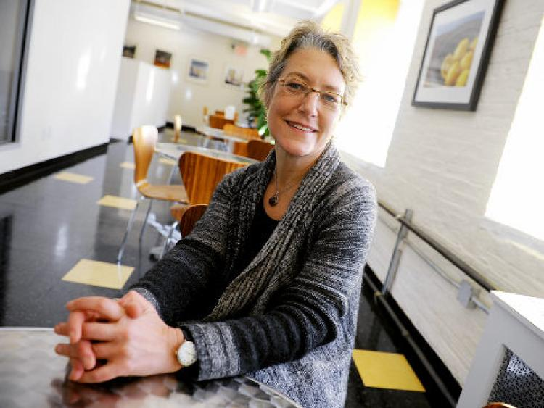**Jennifer King**

**Age**: 55

**Family life**: Single, has 2 cats

From Virginia Beach, VA

**Profession:** Self-employed freelance writer

“Virginia Beach is for lovers”

She is a self-employed freelance writer for years. Before she is writing for Virginia Pilot and other online news outlets in Virginia Beach, she worked at the New York Times in New York City as a political journalist for several years. She moved back to Virginia Beach and became a self-employed freelance writer when her father was aging and needed her care. She is very passionate about finding ways to make Virginia Beach to be a better place to live because she is born and raised in the area. She sees many national and international food chains that came to Virginia Beach area and the local farmers are losing their chances to make money.

Jennifer heard about the “Princess Anne locavore” when she interviewed a local famers and wrote about the challenges that the local famers had. She found the research on locavore interesting and felt that the concept of “eat local, live local” in her community is very important. She is writing a personal blog about local stories. She also pay attentions to any environmental issues that occur in anywhere.

**Concerns:** Jennifer is concerned that not enough local people know about the “Princess Anne locavore” and how this can help with building a heather community in Virginia Beach.  She is concerned that people do not fully understand the opportunities that the “Princess Anne locavore” offers. She also does not know how to keep the “Princess Anne locavore” updated at her community.

**Experience with the “Princess Anne locavore”:** Jennifer had good experience with the “Princess Anne locavore”.  Jennifer would like to have more opportunities to interact with people in the local locavore community, such as famers, distributors, retailers, and consumers and have more in-person interaction. She dislikes the “Princess Anne locavore” Facebook page because she does not like the lack of the information. Jennifer wishes that the “Princess Anne locavore” website has a platform to have more information for promoting locavore in Virginia Beach, she likes to read data, text, and research findings that related to how to build a community and how to promote a healthy life styles.

**Long term goal:** To spread awareness about “live local, eat local”

**Short term goal**:  To promote “Princess Anne locavore” to her community

Persona 2



**Cathy Baker**

**Age**: 45

**Family life**: Married to Allen Baker, has 2 kids- Emily, Age 9  & Jacob, Age 14

From Virginia Beach, VA

**Profession:** Support Services Consultant at Norfolk Virginia Office of the American Diabetes Association

“Taking care of family is key”

She got involved with Norfolk Virginia Office of the American Diabetes Association because her little girl was diagnosed with diabetes at age 6. She is very passionate about finding ways to improve quality of life for people with diabetes and their family members. She loves seeing patients benefit from learning “how to live with diabetes” as well as seeing the smiles on their family members faces when the patients improve.

Cathy heard about the “Princess Anne locavore” when she met the founder of the organization at the Pungo Strawberry Festival in Pungo, Virginia. She found the research on locavore interesting and felt compelled to bring the concept of “eat local, live local” to her organization as well as her own family. She is a trained facilitator and currently oversees 30 student volunteers from Old Dominion University in Norfolk, Virginia. She is always looking for new projects and new ways to innovate at the Norfolk Virginia Office of the American Diabetes Association.

**Concerns:** Cathy is concerned that not enough people with diabetes and their families know about the “Princess Anne locavore” and how this can help with finding a better quality of life.  She is concerned that people do not fully understand the opportunities that the “Princess Anne locavore” offers. She also does not know how to keep the “Princess Anne locavore” updated at her organization and community.

**Experience with the “Princess Anne locavore”:** Overall, she had good experience with the “Princess Anne locavore”.  Cathy would like to have more opportunities to interact with the local locavore community and have more in-person interaction. She dislikes the Princess Anne locavore” Facebook page because she does not like the lack of networking ability. She loves to cook for her family. She wishes to have seasonal recipes that assist her to prepare her fresh food. Cathy wishes that the “Princess Anne locavore” website has a platform to ease the communication between her and other locavore in Virginia Beach, she is a visual learner so she wishes for the site to have more media (videos, pictures, charts, calendars, etc.)

**Long term goal:** To spread awareness about “how to live with diabetes”, specifically locavore to other people and higher education institutions.

**Short term goal**:  To network with other locavore in Virginia Beach to learn more “live local, eat local” and to grow locavore at her association and community.

**VI. Paper prototypes**

The “Princess Ann locavore” in Virginia Beach current only has a Facebook page with very little posts and very few people “likes” the page. The founder is a professional journalist so I will recommend having a less-page webpage design with many visual images for the organization. Some advantages of a less-page site include:

* Its content is presented in simple, easy and workable fashion for the user
* It uses story to compel visitors to action
* It’s seamless, intuitive and easy to digest
* It’s viscerally and emotionally satisfying
* It decreases bounce rates and encourages sharing
* It looks great on all devices[13]

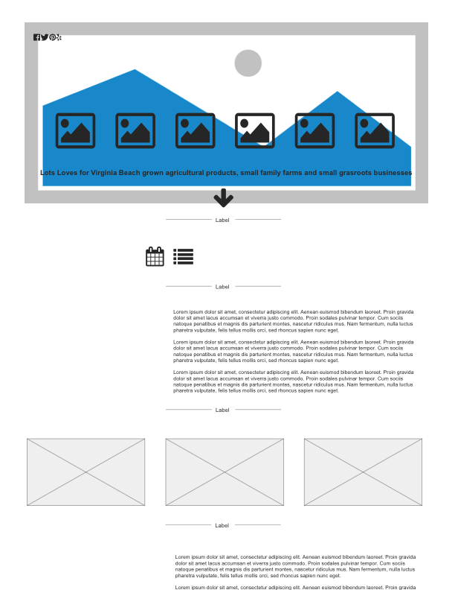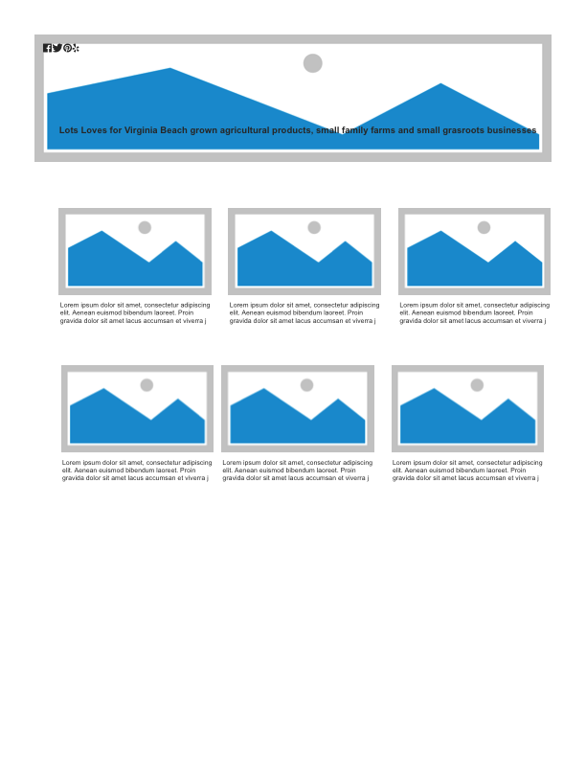**V. Content for the site (provided by client, or generated on your own)**

* Main page | logo with a byline “Lots Loves for Virginia Beach grown agricultural products, small family farms and small grasroots businesses.”
* News section: a calendar format with news updates
* “Why local” section (about section | mission section)
  + good for your health
  + good for your family and loved ones
  + good for the local economy
  + good for the Earth
  + “We are dedicated to the promotion of locally grown produce, agricultural products, and start-up cottage industries in southern Virginia Beach.”
  + I will ask the founder if she has any written articles to share.
* Community section
  + Local locavore page
    - Highlights: Special seasonal recipes
      * Pecan Pie recipe http://www.foodnetwork.com/recipes/ree-drummond/pecan-pie-recipe.html
    - Stories about consumers, uses, famers, “how to”, etc.
      * An example: Locavore supper club feasts on region's bounty http://pilotonline.com/life/flavor/locavore-supper-club-feasts-on-region-s-bounty/article_3c0f8177-c952-5040-8329-2a6de16bd207.html
    - Recipes page | nutrition value
* “Find local” section (Virginia Beach farmers markets section)
  + [Virginia Beach Farmers Market](https://www.vbgov.com/government/departments/agriculture/farmers-market/Pages/default.aspx)
  + [Old Beach Farmers Market](http://www.oldbeachfarmersmarket.com/)
  + [Cullipher Farm Market](http://www.cullipherfarm.com/)
  + [Shore Drive Farmarket](https://www.facebook.com/Shoredrivefarmarket/)
  + [Bay Breeze Farms](https://www.facebook.com/BayBreeze-Farms-110919882224/)
  + [New Earth Farm](http://newearthfarm.org/)
  + [Henley Farms](http://www.henleyfarms.com/)
  + [Pungo Strawberry Festival](http://pungostrawberryfestival.info/)
  + [Flanagan Farms](https://www.facebook.com/Flanagan-Farm-281287837123/)
  + [S & H Produce](http://www.shproduceholland.com/)
* National locavore section
  + Stories about locavore
    - An example: Austin Film Festival Review: An Acquired Taste | http://www.austinchronicle.com/daily/screens/2016-10-16/austin-film-festival-review-an-acquired-taste/
  + Map: Find a CSA in the Washington area: “There are 73 farms around the region offering community-supported agriculture (CSA) programs highlighted here. In a CSA, members stake a claim on part of a farm's harvest by paying a set fee in advance for shares of produce and more”. Find CSAs that serve your area by selecting a pickup location. https://www.washingtonpost.com/graphics/food/csa-community-supported-agriculture-interactive-map/
* Contact us section
  + Email address[14]
  + Social media links

1. Darby, K., Batte, M. T., Ernst, S., & Roe, B. (2008). Decomposing Local: A Conjoint Analysis of Locally Produced Foods. American Journal of Agricultural Economics, 90(2), 476-86.
2. Definition of Locavore by Merriam-Webster (2016). Retrieved from http://www.merriam-webster.com/dictionary/locavore
3. Gussow, J. D. (1999). Dietary guidelines for sustainability: twelve years later. *Journal of Nutrition Education*, *31*(4), 194-200.
4. Ruth-McSwain, A. (2012). Eating green: coverage of the locavore movement. *Journal of Extension*, *50*(5), 5FEA7.
5. Hartman Group. (2008). Consumer understanding of buying local. Hartbeat, 27. Retrieved from: <http://www.hartman-group.com/hartbeat/>
6. Oxford dictionaries word of the year: Frequently asked questions (2016). Retrieved from http://blog.oxforddictionaries.com/word-of-the-year-faq/
7. Alkon, A. H. (2008). From value to values: Sustainable consumption at farmers markets. Agriculture and Human Values, 25(4), 487-498.
8. Brown, C., & Miller, S. (2008). The impacts of local markets: A review of research on farmers markets and community supported agriculture (CSA). American Journal of Agriculture Economics, 90(5), 1296-1302.
9. Brown, A. (2002). Farmers' market research 1940-2000: An inventory and review. American Journal of Alternative Agriculture, 17(4), 167-76.
10. Halweil, B. (2002). Home grown, the case for local food in a global market. World Watch Paper 163, World Watch Institute, Washington.
11. Abel, J., Thomson, J., & Maretzki, A. (1999). Extension's role with farmers' markets: Working with farmers, consumers, and communities. Journal of Extension [On-line], 37(5) Article 5FEA4. Available at: <http://www.joe.org/joe/1999october/a4.php>
12. The “Princess Anne locavore” Facebook Page. Retrieved from https://www.facebook.com/Princess-Anne-locavore-215178378505956/
13. Weller, N. B. (2016). 8 reasons why pageless design is the future of the web. Retrieved from http://www.dtelepathy.com/blog/design/8-reasons-why-pageless-design-is-the-future-of-the-web
14. The “Princess Ann locavore” Facebook page lists the founder’s personal email address. Will recommend the founder to get an organizational email address.